(14) BINARY TREE USING LINKED LIST

#include<stdio.h>
#include<stdlib.h>
struct node {
struct node * lc;
int data;
struct node * rc;
};
struct node * root, * rcptr, * lcptr, * new, * parent, * ptr, * ptr1, * ptr0, * ptr2;
int item, key, top, top1, flag;
struct node * stack[100];
void creation(struct node * ptr, int item) {
int option, newl;
if (ptr != NULL) {
ptr -> data = item;
printf("Does the node %d has left subtree <1/0>\n", item);
scanf("%d", & option);
if (option == 1) {
lcptr = malloc(sizeof(struct node));
ptr -> lc = lcptr;
printf("Enter the item to be inserted\n");
scanf("%d", & newl);
creation(lcptr, newl);
} else
ptr -> lc = NULL;
printf("Does the node %d has left subtree <1/0>\n", item);
scanf("%d", & option);
if (option == 1) {
rcptr = malloc(sizeof(struct node));
ptr -> rc = rcptr;
printf("Enter the item to be inserted\n");
scanf("%d", & newl);
creation(rcptr, newl);
} else
ptr -> rc = NULL;
}
}
void push(struct node * ptr) {
top = top + 1;
stack[top] = ptr;
}
struct node * pop() {
if (top != -1) {
ptr = stack[top];
top = top - 1;
return ptr;
}
}
struct node * search_link(struct node * ptr, int key) {
struct node * ptr3, * ptr4;
push(ptr);
while (top != -1) {
ptr = pop();
if (ptr != NULL) {
ptr3 = ptr -> lc;
ptr4 = ptr -> rc;
if (ptr -> data == key)
ptr2 = ptr;
if (ptr3 != NULL)
push(ptr4);
if (ptr != NULL)
push(ptr3);
}
}
if (ptr2 -> data != key)
return NULL;
else
return ptr2;
}
void insertion(int key, int item) {
int option;
ptr = search_link(ptr0, key);
if (ptr == NULL)
printf("Search unsucessful\n\t");
else {
if (ptr -> lc == NULL || ptr -> rc == NULL) {
printf("\nleft or right child<1,0>");
scanf("%d", & option);
if (option == 1) {
if (ptr -> lc == NULL) {
new = malloc(sizeof(struct node));
new -> data = item;
new -> lc = new -> rc = NULL;
ptr -> lc = new;
} else
printf("\nInsertion not possible as left child");
} else {
if (ptr -> rc == NULL) {
new = malloc(sizeof(struct node));
new -> data = item;
new -> lc = new -> rc = NULL;
ptr -> rc = new;
} else
printf("\nInsertion not possible as right child");
}
} else
printf("\nThe key node already has child");
}
}
void inorder(struct node * ptr1) {
if (ptr1 != NULL) {
inorder(ptr1 -> lc);
printf("%d\t", ptr1 -> data);
inorder(ptr1 -> rc);
}
}
void preorder(struct node * ptr1) {
if (ptr1 != NULL) {
printf("%d\t", ptr1 -> data);
preorder(ptr1 -> lc);
preorder(ptr1 -> rc);
}
}
void postorder(struct node * ptr1) {
if (ptr1 != NULL) {
postorder(ptr1 -> lc);
postorder(ptr1 -> rc);
printf("%d\t", ptr1 -> data);
}
}
struct node * search_parent(struct node * ptr, int item) {
struct node * ptr3, * ptr4;
top = -1;
flag = 0;
push(ptr);
while (ptr -> data != item) {
ptr = pop();
if (ptr != NULL) {
ptr3 = ptr -> lc;
ptr4 = ptr -> rc;
if (ptr -> data == item) {
flag = 1;
break;
}
if (ptr3 != NULL) {
parent = ptr;
push(ptr3);
}
if (ptr4 != NULL) {
parent = ptr;
push(ptr4);
}
}
}
if (flag == 0)
return NULL;
else
return parent;
}
void deletion(int item) {
struct node * c;
ptr = root;
if (ptr == NULL)
printf("\nTree is empty\n\t");
else {
if (ptr -> rc == NULL && ptr -> lc == NULL) {
root -> data = 0;
ptr0 = ptr1 = NULL;
return;
}
parent = search_parent(ptr, item);
if (parent == NULL)
printf("Parent node not found\n");
else {
if (parent -> lc != NULL) {
c = parent -> lc;
if (c -> data == item) {
parent -> lc = NULL;
c -> data = 0;
c -> lc = NULL;
c -> rc = NULL;
free(c);
}
}
if (parent -> rc != NULL) {
c = parent -> rc;
if (c -> data == item) {
parent -> rc = NULL;
c -> data = 0;
c -> lc = NULL;
c -> rc = NULL;
free(c);
}
}
}
}
}
void main() {
int choice, k = 0;
root = malloc(sizeof(struct node));
root -> lc = NULL;
root -> rc = NULL;
printf("\n1.Creation\n2.Insertion\n3.Deletion\n4.inorder\n5.Postorder\n6.Preorder\n");
while (k == 0) {
printf("choice : ");
scanf("%d", & choice);
switch (choice) {
case 1:
printf("Enter the item to be inserted at root node\n");
scanf("%d", & item);
creation(root, item);
ptr1 = root;
ptr0 = root;
break;
case 2:
if (ptr1 != NULL) {
printf("Enter the key node after which new node to be inserted\n");
scanf("%d", & key);
printf("\nEnter the item to be inserted\n\t");
scanf("%d", & item);
insertion(key, item);
} else
printf("Create tree first then press this option");
break;
case 3:
if (ptr1 != NULL) {
printf("\nEnter the leaf node to be deleted");
scanf("%d", & item);
deletion(item);
} else
printf("\nNo tree created\n\t");
break;
case 4:
inorder(ptr1);
break;
case 5:
postorder(ptr1);
break;
case 6:
preorder(ptr1);
break;
default:
exit(0);
}
}
}
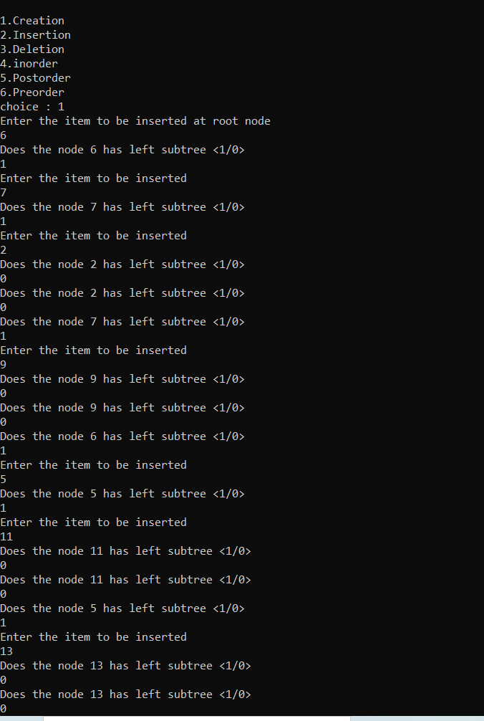
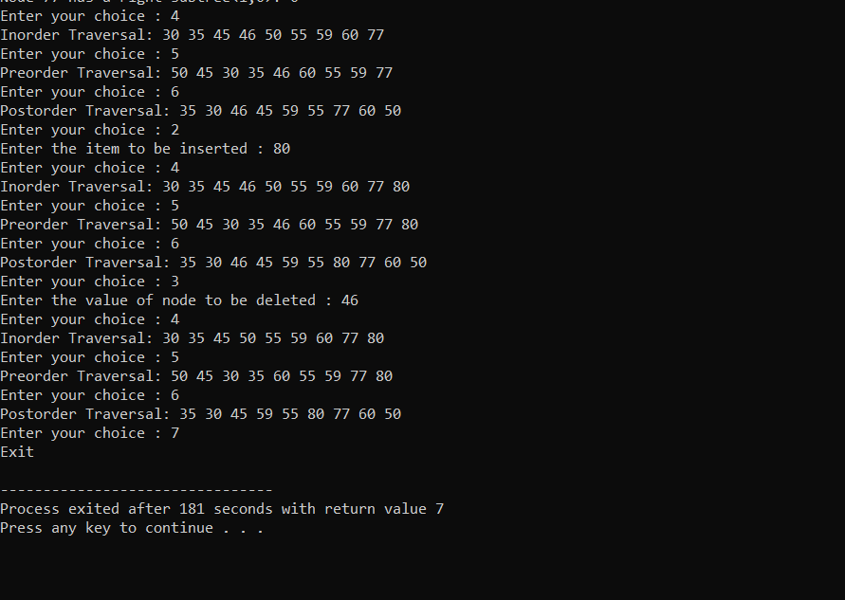

(15) GRAPH USING ADJACENCY MATRIX BFS AND DFS
#include<stdio.h>
#include<stdlib.h>
#define MAX 100
#define initial 1
#define visited 2
void graph_traversal_D();
void graph_traversal_B();
void DFS(int vertex);
void BFS(int vertex);
void make_graph();
void push(int vertex);
int pop();
int isEmpty_D();
void enqueue(int vertex);
int dequeue();
int isEmpty_B();
int top = -1, front = -1, rear = -1, vertices, ;
int stack[MAX], queue[MAX], adjacent_matrix[MAX][MAX], vertex_status[MAX];;
void main() {
int choice;
printf("GRAPH TRAVERSAL USING ADJASCENCY MATRIX\n");
do {
printf("\n 1:Depth First Search\n 2:Breadth First Search\n 3:Exit\n");
printf("Enter your choice : ");
scanf("%d", & choice);
switch (choice) {
case 1:
printf("\n\tDFS TRAVERSAL\n\n");
make_graph();
graph_traversal_D();
break;
case 2:
printf("\n\tBFS TRAVERSAL\n\n");
make_graph();
graph_traversal_B();
break;
case 3:
break;
default:
printf("\nInvalid choice\n");
}
} while (choice != 3);
}
void graph_traversal_D() {
int vertex;
for (vertex = 0; vertex < vertices; vertex++) {
vertex_status[vertex] = initial;
}
printf("Enter Starting Vertex for DFS:\t");
scanf("%d", & vertex);
DFS(vertex);
printf("\n");
}
void DFS(int vertex) {
int count;
push(vertex);
while (!isEmpty_D()) {
vertex = pop();
if (vertex_status[vertex] == initial) {
printf("%3d", vertex);
vertex_status[vertex] = visited;
}
for (count = vertices - 1; count >= 0; count--) {
if (adjacent_matrix[vertex][count] == 1 && vertex_status[count] == initial) {
push(count);
}
}
}
}
void push(int vertex) {
if (top == (MAX - 1)) {
printf("Stack Overflow\n");
return;
}
top = top + 1;
stack[top] = vertex;
}
int pop() {
int vertex;
if (top == -1) {
printf("Stack Underflow\n");
exit(1);
} else {
vertex = stack[top];
top = top - 1;
return vertex;
}
}
int isEmpty_D() {
if (top == -1) {
return 1;
} else {
return 0;
}
}
void graph_traversal_B() {
int vertex;
for (vertex = 0; vertex < vertices; vertex++) {
vertex_status[vertex] = initial;
}
printf("Enter Starting Vertex for BFS:\t");
scanf("%d", & vertex);
BFS(vertex);
printf("\n");
}
void BFS(int vertex) {
int count;
enqueue(vertex);
while (!isEmpty_B()) {
vertex = dequeue();
if (vertex_status[vertex] == initial) {
printf("%3d", vertex);
vertex_status[vertex] = visited;
}
for (count = vertices - 1; count >= 0; count--) {
if (adjacent_matrix[vertex][count] == 1 && vertex_status[count] == initial) {
enqueue(count);
}
}
}
}
void enqueue(int vertex) {
if (rear == (MAX - 1))
printf("Queue Overflow\n");
else {
if (front == -1) {
front = rear = 0;
queue[rear] = vertex;
} else
queue[++rear] = vertex;
}
}
int dequeue() {
int vertex;
if (front == -1) {
printf("Queue Underflow\n");
exit(1);
} else {
vertex = queue[front];
if (front == rear) {
front = rear = -1;
} else front++;
return vertex;
}
}
int isEmpty_B() {
if (front == -1) {
return 1;
} else {
return 0;
}
}
void make_graph() {
int count, maximum_edges, origin_vertex,
destination_vertex;
printf("Enter total number of
vertices: \t "); scanf(" % d ", &vertices);
maximum_edges = vertices * (vertices - 1);
for (count = 0; count < maximum_edges; count++) {
printf("Enter Edge [%d] Co-ordinates [-1 -1] to Quit\n", count +
1);
printf("Enter Origin Vertex Point:\t");
scanf("%d", &
origin_vertex);
printf("Enter Destination Vertex Point:\t");
scanf("%d", & destination_vertex);
if ((origin_vertex == -1) && (destination_vertex == -1)) {
break;
}
if (origin_vertex >= vertices || destination_vertex >= vertices || origin_vertex <
0 || destination_vertex < 0) {
printf("\tEdge Co - ordinates are Invalid\n");
count--;
} else {
adjacent_matrix[origin_vertex][destination_vertex] = 1;
}
}
}
}

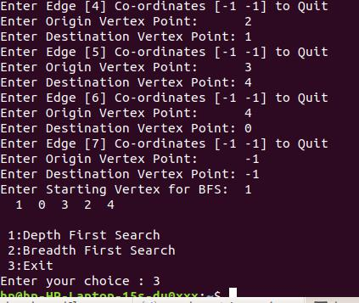
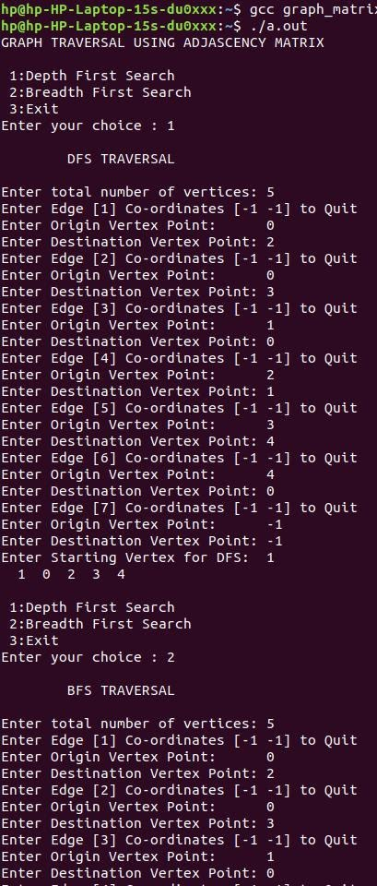
16) QUICK SORT, HEAP SORT, MERGE SORT
#include<stdio.h>
int a[20], b[20], h[20], length, heapsize;
void exchange(int * a, int * largest);
void display(int b[]);
void heapify(int a[], int i);
void buildheap(int a[]);
void heapsort(int a[]);
void quick(int x[], int first, int last);
int partition(int x[], int first, int last);
int mergesort(int a[], int p, int r);
int merge(int a[], int p, int q, int s);
void quick(int x[], int first, int last) {
int pivot;
if (first < last) {
pivot = partition(x, first, last);
quick(x, first, pivot - 1);
quick(x, pivot + 1, last);
}
}
int partition(int x[], int first, int last) {
int pivot, temp, i, j;
pivot = first;
i = first;
j = last;
while (i < j) {
while ((x[i] <= x[pivot]) && (i < last))
i++;
while (x[j] > x[pivot])
j--;
if (i < j) {
temp = x[i];
x[i] = x[j];
x[j] = temp;
}
}
temp = x[pivot];
x[pivot] = x[j];
x[j] = temp;
return j;
}
int mergesort(int a[], int p, int r) {
int q;
if (p < r) {
q = (p + r) / 2;
mergesort(a, p, q);
mergesort(a, q + 1, r);
merge(a, p, q, r);
}
return 0;
}
int merge(int a[], int p, int q, int s) {
int n1, n2, l[10], r[10], i, j, k;
n1 = q - p + 1;
n2 = s - q;
for (i = 0; i < n1; i++)
l[i] = a[p + i];
for (j = 0; j < n2; j++)
r[j] = a[q + j + 1];
l[i] = 9999;
r[j] = 9999;
i = 0;
j = 0;
for (k = p; k <= s; k++) {
if (l[i] <= r[j]) {
a[k] = l[i];
i = i + 1;
} else {
a[k] = r[j];
j = j + 1;
}
}
return 0;
}
void exchange(int * a, int * largest) {
int temp;
temp = * a;
* a = * largest;
* largest = temp;
}
void display(int b[]) {
int i;
for (i = 1; i <= length; i++)
printf("\t%d", b[i]);
}

void heapify(int a[], int i) {
int left, right, largest;
left = 2 * i;
right = 2 * i + 1;
if (left <= heapsize && a[left] > a[i])
largest = left;
else
largest = i;
if (right <= heapsize && a[right] > a[largest])
largest = right;
if (largest != i) {
exchange( & a[i], & a[largest]);
heapify(a, largest);
}
}

void buildheap(int a[]) {
int i, j, x;
i = 1;
while (i <= length) {
x = a[i];
h[i] = x;
j = i;
while (j > 1) {
if (h[j] > h[j / 2]) {
exchange( & h[j], & h[j / 2]);
j = j / 2;
} else
j = 1;
}
i = i + 1;
}
}

void heapsort(int a[]) {
int i;
buildheap(a);
printf("\nArray after creating heap\n");
display(h);
for (i = length; i >= 2; i--) {
exchange( & h[1], & h[i]);
heapsize = heapsize - 1;
heapify(h, 1);
}
}

void main() {
int i, j, n, c, ch;
do {
printf("\nEnter your choice:\n\t1.Quicksort\n\t2.Mergesort.\n\t3.Heapsort\n\t4.Exit\n");
scanf("%d", & ch);
switch (ch) {
case 1:
printf("\nEnter the no. of elements in the array:\t");
scanf("%d", & n);
printf("\nEnter the elements into the array:\n");
for (i = 1; i <= n; i++)
scanf("%d", & a[i]);
quick(a, 1, n);
printf("\nThe sorted array using quicksort is:\n");
for (i = 1; i <= n; i++)
printf("%d\t", a[i]);
break;
case 2:
printf("\nEnter the no of elements in the array:\t");
scanf("%d", & n);
printf("\nEnter the elements into the array:\n");
for (i = 0; i < n; i++)
scanf("%d", & b[i]);
mergesort(b, 0, n - 1);
printf("\nThe sorted array using mergesort is:\n");
for (i = 0; i < n; i++)
printf("%d\t", b[i]);
break;
case 3:
printf("\nEnter the no. of elements in the array:\t");
scanf("%d", & n);
printf("\nEnter the elements into the array:\n");
for (i = 1; i <= n; i++)
scanf("%d", & a[i]);
length = n;
heapsize = length;
heapsort(a);
printf("\nThe sorted array using heapsort is:\n")
display(h);
break;
case 4:
break;
default:
printf("ERROR! Invalid Choice.., Try Again!!!\n");
break;
}
} while (ch != 4);
}
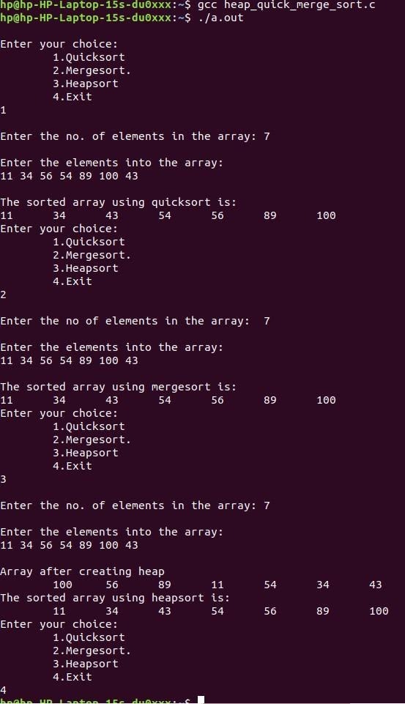
(17)GRAPH USING ADJACENCY LIST
BFS

#include<stdio.h>
#include<stdlib.h>
struct node1 {
int data;
struct node1 * next;
}* visit = NULL;
struct node {
int data;
struct node * link;
struct node1 * alink;
}* gptr = NULL;
int front = -1, rear = -1;
int que[10];
void enqueue(int item) {
if (rear == 10)
printf("Queue is full");
else {
if (front == -1) {
front = rear = 0;
que[rear] = item;
} else
que[++rear] = item;
}
}
int dequeue() {
if (front == -1)
return -1;
else {
int x = que[front];
if (front == rear) {
front = rear = -1;
} else front++;
return (x);
}
}
int searchVisit(int vert) {
struct node1 * p;
p = visit;
if (p == NULL)
return 0;
else
while ((p != NULL) && (p -> data != vert)) {
p = p -> next;
}
if (p != NULL)
return 1;
elsereturn 0;
}
void addVisit(int vert) {
struct node1 * p, * new;
p = visit;
if (p == NULL) {
new = malloc(sizeof(struct node1));
new -> data = vert;
new -> next = NULL;
visit = new;
} else {
while (p -> next != NULL)
p = p -> next;
new = malloc(sizeof(struct node1));
new -> data = vert;
new -> next = NULL;
p -> next = new;
}
}
void bfs(struct node * gptr, int s) {
struct node * temp;
struct node1 * temp1;
int u = s;
enqueue(u);
while (front != -1) {
u = dequeue();
if (searchVisit(u) == 0) {
printf("%3d", u);
addVisit(u);
temp = gptr;
while ((temp != NULL) && (temp -> data != u))
temp = temp -> link;
temp1 = temp -> alink;
while (temp1 != NULL) {
enqueue(temp1 -> data);
temp1 = temp1 -> next;
}
}
}
}
void display(struct node * g) {
struct node * ptr;
struct node1 * ptr1;
ptr = g;
while (ptr != NULL) {
printf("\nNode : %d", ptr -> data);
ptr1 = ptr -> alink;
while (ptr1 != NULL) {
printf("..%3d..", ptr1 -> data);
ptr1 = ptr1 -> next;
}
ptr = ptr -> link;
}
}
void main() {
int m, n, opt, yes;
struct node * temp, * temp1;
struct node1 * ptr, * ptr1, * ptr2;
int start;
printf("\nHow many nodes?");
scanf("%d", & n);
for (int i = 1; i <= n; i++) {
temp = malloc(sizeof(struct node));
printf("Enter the vertex in the graph:");
scanf("%d", & temp -> data);
if (gptr == NULL) {
gptr = temp;
temp1 = temp;
} else {
temp1 -> link = temp;
temp1 = temp;
}
temp -> link = NULL;
printf("\n Any edges starting from vertex [1/0] ");
scanf("%d", & yes);
if (yes == 1) {
printf("\n Enter the nodes with which this node shares an edge :");
ptr1 = NULL;
do {
ptr = malloc(sizeof(struct node1));
printf("\nEnter the vertex:");
scanf("%d", & ptr -> data);
if (ptr1 == NULL) {
ptr1 = ptr;
ptr2 = ptr;
} else {
ptr2 -> next = ptr;
ptr2 = ptr;
}
printf("\nAnymore adjascent nodes??[1/0] :");
scanf("%d", & opt);
} while (opt == 1);
ptr2 -> next = NULL;
temp -> alink = ptr1;
} else
temp -> alink = NULL;
}
printf("\n Enter the start vertex :");
scanf("%d", & start);
bfs(gptr, start);
}

DFS

#include<stdio.h>
#include<stdlib.h>
struct node1 {
int data;
struct node1 * next;
}* visit = NULL;

struct node {
int data;
struct node * link;
struct node1 * alink;
}* gptr = NULL;
int top = -1;
int stack[10];

void push(int item) {
if (top == 10) {
printf("Stack is full");
} else {
stack[++top] = item;
}
}

int pop() {
if (top == -1) {
return -1;
} else {
return (stack[top--]);
}
}
int searchVisit(int vert) {
struct node1 * p;
p = visit;
if (p == NULL)
return 0;
else
while ((p != NULL) && (p -> data != vert)) {
p = p -> next;
}
if (p != NULL)
return 1;
else
return 0;
}

void addVisit(int vert) {
struct node1 * p, * new;
p = visit;
if (p == NULL) {
new = malloc(sizeof(struct node1));
new -> data = vert;
new -> next = NULL;
visit = new;
} else {
while (p -> next != NULL)
p = p -> next;
new = malloc(sizeof(struct node1));
new -> data = vert;
new -> next = NULL;
p -> next = new;
}
}

void dfs(struct node * gptr, int s) {
struct node * temp;
struct node1 * temp1;
int u = s;
push(u);
while (top != -1) {
u = pop();
if (searchVisit(u) == 0) {
printf("%3d", u);
addVisit(u);
temp = gptr;
while ((temp != NULL) && (temp -> data != u))
temp = temp -> link;
temp1 = temp -> alink;
while (temp1 != NULL) {
push(temp1 -> data);
temp1 = temp1 -> next;
}
}
}
}

void display(struct node * g) {
struct node * ptr;
struct node1 * ptr1;
ptr = g;
while (ptr != NULL) {
printf("\nNode : %d", ptr -> data);
ptr1 = ptr -> alink;
while (ptr1 != NULL) {
printf("..%3d..", ptr1 -> data);
ptr1 = ptr1 -> next;
}
ptr = ptr -> link;
}
}
void main() {
int m, n, opt, yes;
struct node * temp, * temp1;
struct node1 * ptr, * ptr1, * ptr2;
int start;
printf("\nHow many nodes?");
scanf("%d", & n);
for (int i = 1; i <= n; i++) {
temp = malloc(sizeof(struct node));
printf("Enter the vertex in the graph:");
scanf("%d", & temp -> data);
if (gptr == NULL) {
gptr = temp;
temp1 = temp;
} else {
temp1 -> link = temp;
temp1 = temp;
}
temp -> link = NULL;
printf("\n Any edges starting from vertex[1/0] ");
scanf("%d", & yes);
if (yes == 1) {
printf("\n Enter the nodes with which this node shares an edge :");
ptr1 = NULL;
do {
ptr = malloc(sizeof(struct node1));
printf("\nEnter the vertex:");
scanf("%d", & ptr -> data);
if (ptr1 == NULL) {
ptr1 = ptr;
ptr2 = ptr;
} else {
ptr2 -> next = ptr;
ptr2 = ptr;
}
printf("\nAnymore adjascent nodes??[1/0] :");
scanf("%d", & opt);
} while (opt == 1);
ptr2 -> next = NULL;
temp -> alink = ptr1;
} else
temp -> alink = NULL;
}
printf("\n Enter the start vertex :");
scanf("%d", & start);
dfs(gptr, start);
}

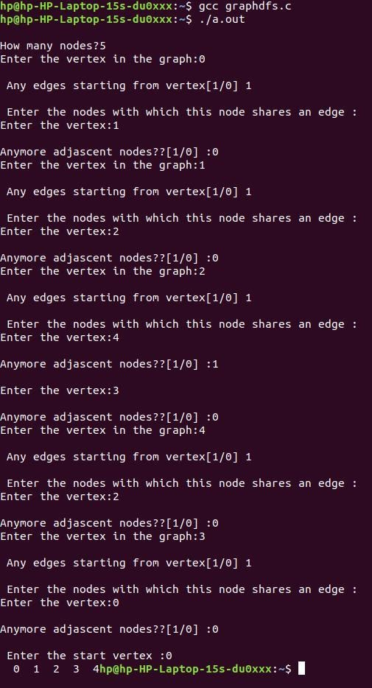

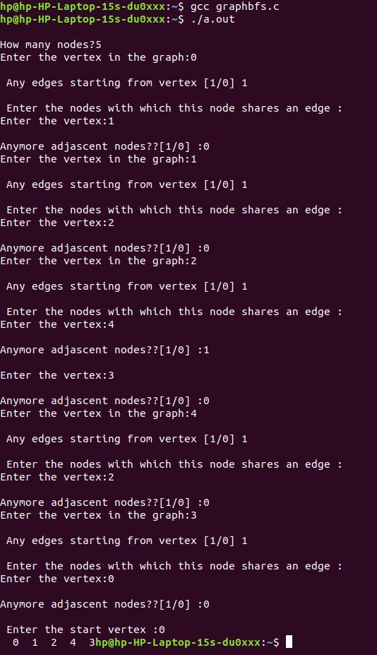

(18) HASH TABLE USING CHAINING MEHOD
#include <stdio.h>
#include <stdlib.h>
#define TABLE_SIZE 10
struct node {
int data;
struct node * next;
};
struct node * head[TABLE_SIZE] = {
NULL
}, * c;
void insert() {
int i, key;
printf("Enter a value to insert into hash table :");
scanf("%d", & key);
i = key % TABLE_SIZE;
struct node * newnode = (struct node * ) malloc(sizeof(struct node));
newnode -> data = key;
newnode -> next = NULL;
if (head[i] == NULL)
head[i] = newnode;
else {
c = head[i];
while (c -> next != NULL) {
c = c -> next;
}
c -> next = newnode;
}
}
void search() {
int key, index;
printf("Enter the element to be searched :");
scanf("%d", & key);
index = key % TABLE_SIZE;
if (head[index] == NULL)
printf("Search element not found\n");
else {
for (c = head[index]; c != NULL; c = c -> next) {
if (c -> data == key) {
printf("search element found\n");
break;
}
}
if (c == NULL)
printf("Search element not found\n");
}
}
void display() {
int i;
for (i = 0; i < TABLE_SIZE; i++) {
printf("\nEntries at index %d\n", i);
if (head[i] == NULL) {
printf("No Hash Entry");
} else {
for (c = head[i]; c != NULL; c = c -> next) printf("%d->", c -> data);
}
}
}
void main() {
int i, choice;
printf("\nIMPLEMENTATION OF HASH TABLE USING CHAINING METHOD FOR COLLISION RESOLUTION\n");
printf("1:Insert\n 2:Display\n 3:Search\n 4:Exit \n");
while (choice != 4) {
switch (choice) {
case 1:
insert();
break;
case 2:
display();
break;
case 3:
search();
break;
case 4:
break;
}
printf("Enter your choice :");
scanf("%d", & choice);
}
}

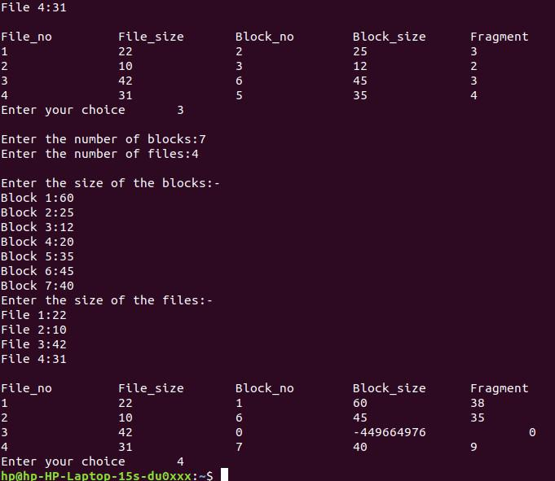

(19) HASH TABLE USING LINEAR PROBING COLLISION RES
#include<stdio.h>
int H[10];
void Insert(int key);
void Display();
void Search(int key);
void Delete(int key);
void main() {
int x, key, i;
for (i = 0; i < 10; i++)
H[i] = -1;
printf("Choices are\n1)Insertion\n2)Display\n3)Search\n4)Deletion\n5)Exit\n");
while (x != 5) {
printf("Enter your choice : ");
scanf("%d", & x);
switch (x) {
case 1:
printf("Enter the element to be inserted : ");
scanf("%d", & key);
Insert(key);
break;
case 2:
printf("Hash Table\n");
Display();
break;
case 3:
printf("Enter the key to be searched : ");
scanf("%d", & key);
Search(key);
break;
case 4:
printf("Enter the key to be deleted : ");
scanf("%d", & key);
Delete(key);
break;
case 5:
printf("Exit\n");
break;
default:
printf("Invelid choice\n");
break;
}
}
}
void Insert(int key) {
int i, j;
i = key % 10;
if (H[i] == -1) {
H[i] = key;
} else {
for (j = (i + 1) % 10; j != i; j = (j + 1) % 10) {
if (H[j] == -1) {
H[j] = key;
break;
}
}
if (j == i) {
printf("The table is overflow\n");
}
}
}
void Display() {
int i;
for (i = 0; i < 10; i++) {
printf("%d ", i);
if (H[i] != -1)
printf("%d", H[i]);
printf("\n");
}
}
void Search(int key) {
int i, j, insert;
i = key % 10;
if (H[i] == key) {
printf("Key is found at the index %d\n", i);
return;
} else {
j = (i + 1) % 10;
while (j != i) {
if (H[j] == key) {
printf("Key is found at the index %d\n", j);
return;
} else {
j = (j + 1) % 10;
}
}
if (j == i) {
printf("Key value does not exist\n");
printf("Do you want to insert this key(Give option 1/0) ?");
scanf("%d", & insert);
if (insert == 1) {
Insert(key);
}
}
}
}
void Delete(int key) {
int i, j;
i = key % 10;
if (H[i] == key) {
H[i] = -1;
return;
} else {
j = i + 1;
while (j != i) {
if (H[j] == -1) {
printf("Key does not exist : No deletion\n");
return;
} else if (H[j] == key) {
H[j] = -1;
return;
} else {
j = (j + 1) % 10;
}
}
if (j == i) {
printf("Key does not exist : No deletion\n");
}
}
}
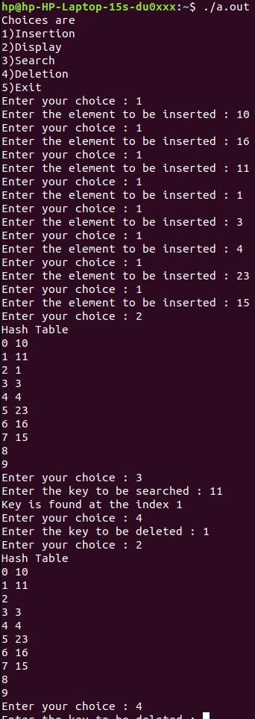
(20) DYNAMIC MEMORY ALLOCATION AND DEALLOCATION
#include<stdio.h>
#define max 25
void FirstFit();
void BestFit();
void WorstFit();
void makeallo() {
int frag[max], b[max], f[max], i, j, nb, nf, temp;
static int bf[max], ff[max];
printf("\nEnter the number of blocks:");
scanf("%d", & nb);
printf("Enter the number of files:");
scanf("%d", & nf);
printf("\nEnter the size of the blocks:-\n");
for (i = 1; i <= nb; i++) {
printf("Block %d:", i);
scanf("%d", & b[i]);
}
printf("Enter the size of the files:-\n");
for (i = 1; i <= nf; i++) {
printf("File %d:", i);
scanf("%d", & f[i]);
}
}

void FirstFit() {
int frag[max], b[max], f[max], i, j, nb, nf, temp;
static int bf[max], ff[max];
for (i = 1; i <= nf; i++) {
for (j = 1; j <= nb; j++) {
if (bf[j] != 1) {
temp = b[j] - f[i];
if (temp >= 0) {
ff[i] = j;
break;
}
}
}
frag[i] = temp;
bf[ff[i]] = 1;
}
printf("\nFile_no:\tFile_size :\tBlock_no:\tBlock_size:\tFragment");
for (i = 1; i <= nf; i++)
printf("\n%d\t\t%d\t\t%d\t\t%d\t\t%d", i, f[i], ff[i], b[ff[i]], frag[i]);
}

void BestFit() {
int frag[max], b[max], f[max], i, j, nb, nf, temp, lowest = 10000;
static int bf[max], ff[max];
for (i = 1; i <= nf; i++) {
for (j = 1; j <= nb; j++) {
if (bf[j] != 1) {
temp = b[j] - f[i];
if (temp >= 0)
if (lowest > temp) {
ff[i] = j;
lowest = temp;
}
}
}
frag[i] = lowest;
bf[ff[i]] = 1;
lowest = 10000;
}
printf("\nFile_no \tFile_size \tBlock_no \tBlock_size \tFragment");
for (i = 1; i <= nf && ff[i] != 0; i++)
printf("\n%d\t\t%d\t\t%d\t\t%d\t\t%d", i, f[i], ff[i], b[ff[i]], frag[i]);
}

void WorstFit() {
int frag[max], b[max], f[max], i, j, nb, nf, temp, highest = 0;
static int bf[max], ff[max];
for (i = 1; i <= nf; i++) {
for (j = 1; j <= nb; j++) {
if (bf[j] != 1) //if bf[j] is not allocated
{
temp = b[j] - f[i];
if (temp >= 0)
if (highest < temp) {
ff[i] = j;
highest = temp;
}
}
}
frag[i] = highest;
bf[ff[i]] = 1;
highest = 0;
}
printf("\nFile_no \tFile_size \tBlock_no \tBlock_size \tFragment");
for (i = 1; i <= nf; i++)
printf("\n%d\t\t%d\t\t%d\t\t%d\t\t%d", i, f[i], ff[i], b[ff[i]], frag[i]);
}

void main() {
int choice;
printf("\nVariable Sized Dynamic Memory Allocation \n");
printf("\nChoices:\n 1:FIRST FIT\n 2:BEST FIT\n 3:WORST FIT\n 4:EXIT\n\n");
do {
printf("\nEnter your choice\t");
scanf("%d", & choice);
switch (choice) {
case 1:
makeallo();
FirstFit();
break;
case 2:
makeallo();
BestFit();
break;
case 3:
makeallo();
WorstFit();
break;
case 4:
break;
default:
printf("\nInvalid Choice\n");
}
} while (choice != 4);
}
